**Livant Enterprises:**

**Relational Database System Design Document**

**LivantEnterprises-RDBMSDD-1.0.0-Initial System**



Prepared for:

URI Pharmacy Outreach Program Relational Database Management System

College of Pharmacy

7 Greenhouse Road, Kingston, RI 02881

(401) 874-7485

September 1, 2018

Table of Contents

List of Acronyms and Terms 4

Revision History 6

Scope 7

Document Identification 7

Project Overview 7

Related Documents 7

MySQL 7

VBA for Excel 7

Contacts 8

Creating the University of Rhode Island Pharmacy Outreach Program Relational Database Management System 9

Conceptual Models 10

System Context 10

Purpose of Database 10

Data and User Experience Description 12

Comprehensive Medication Review (CMR) or Targeted Medication Review (TMR) 12

Session Information 12

Demographics 12

Prescription Medication Review 13

Immunizations Review 13

Survey after MTM Services 13

Printable Forms 13

CMR/TMR Tables for Drop Down Lists or Check Boxes 13

Session Information: 14

Prescription Medication Review 15

Immunizations Review 22

Diabetes Education and Support Session (DESS) 24

Demographics 24

Diabetes Counseling Session 24

DESS Tables for Drop Down Lists or Check Boxes 26

Demographics: 26

Session Information: 27

Diabetes laboratories 27

Health Care Utilization 28

Logical Organization of Data 29

Session 29

Demographics 29

Insurance 30

Pharmacy 30

Prescriber 30

Health Data 30

Immunizations 30

Patient Diabetes Behavior Information 30

Drug 31

Survey 31

Med Review – TMR / also used in CMR 32

Materials Delivered 32

Logical Design and Models 33

Conceptual Model for Database 33

System Schema Design Model 34

Administration Model 35

Session Model – export finished database with screenshots of end user functioning 35

Patient Model 36

Data Usage – Data Movement and ETL ? Extract, Transform and Load 37

Data Ownership – data sources 37

Data and Functions 37

Business Rules 37

Physical Model 38

Table Models and Data Dictionary 38

Physical Organization 38

Database Constraints and Triggers 38

Performance Features 38

Security 38

Backup and Recovery 38

Software Activity Diagram 39

System Deployment Diagram 41

Notes 42

Requirements Traceability 43

List of Tables

Revisions 7

Tools 10

System Context Diagram 11

System Activity Diagram 12

Table 3 25

System Schema Design Model 35

Administration Model 36

Patient Model 37

List of Acronyms and Terms

A1C............................Average blood glucose levels over the past 3 months

Adherence...................The degree to which a patient correctly follows medical advice.

Cholesterol...................An essential substance that is produced by the body but is also ingested from animal-derived foods

CMR...........................Comprehensive Medication Review

CRUD ........................Create, Reference, Update, Delete

BMI............................Body Mass Index

DBDD........................Database Design Document

DESS..........................Diabetes Education and Support Session

Diastolic........................The blood pressure bottom number, is the pressure in the arteries when the heart rests between beats.

ERD............................Entity Relationship Model

ETL............................Extract, Transform and Load

Formulary.................. A list of prescription drugs covered by a prescription drug plan or another insurance plan offering prescription drug benefits. Also called a drug list.

HDL............................ High-density lipoproteins

HIPPA........................Health Insurance Portability and Accountability Act

Indication...................Reason for treatment

IRB.............................Institutional Review Board

LDL.............................Low-density lipoprotein

MAP...........................Medication Action Plan

MRP...........................Medication Related Problem

MTM..........................Medication Therapy Management

Prandial...................... Prandial relates to a meal.

RPH...........................Registered Pharmacist

SQL............................Structured Query Language

Systolic.......................The time at which ventricular contraction occurs is called systole. In a blood pressure reading, the systolic pressure is typically the first number recorded.

TBD............................To Be Determined

TMR...........................Targeted Medication Review

Triglycerides...............Main constituents of body fat in humans and other animals, as well as vegetable fat.

VBA...........................Visual Basic for Applications

# Revision History

|  |  |  |
| --- | --- | --- |
| Revision | Date | Changes |
| 1.0.0- Preliminary | August 10, 2018 | Download new system components, create test system and test functioning |
| 1.0.1-Component Test | August 21, 2018 | First Working Test System |
| 1.0.2-User Interface Completed | August 26, 2018 | Front End Working |
| 1.0.3-ER Design Completed | August 28, 2018 | Database Design Drafted |
| 1.0.4-Database Completed | December 27, 2018 | Database built and populated with test data / functioning and constraints confirmed/ no triggers or stored procedures |
| 1.0.5-User Interface Beta Tested | September 18, 2018 | Initial beta testing by Noemi |
|  |  |  |
|  |  |  |
|  |  |  |
|  |  |  |
|  |  |  |
|  |  |  |
|  |  |  |
|  |  |  |
|  |  |  |
|  |  |  |
|  |  |  |
|  |  |  |
|  |  |  |
|  |  |  |
|  |  |  |
|  |  |  |

Revisions

# Scope

## Document Identification

This document serves as the Relational Database System Design Document (RDBMSDD) for the University of Rhode Island Pharmacy Outreach Program Database System.

## Project Overview

The University of Rhode Island Pharmacy Outreach Program needs a new relational database system that will allow the program to conduct comprehensive medication reviews, targeted medication reviews and diabetes education support sessions. This program provides services at local adult daycare centers and correctional facilities in Providence, RI. The current RDBMS is deployed in an Access 2007 database and front-end user system that is slow to update and does not provide for easy report generation. The larger problem is with Microsoft Office 365, Access is in the cloud and is a violation of compliance with HIPPA and IRB regulations. The new system will provide dependable, secure data storage and retrieval. The new database will provide needed services such as saving and linking successive sessions with the same patients and report generation for the patients and their health care providers. The new system will facilitate efficient data analysis. Additionally, the new system will be maintainable in the long-term.

The Livant Enterprises relational database management system development effort was set to span approximately 14 weeks. The initial data and system requirement collection took 9 weeks and the database design took 3 weeks. After the development, the software will be deployed to Dr. Noemi Ramos-DeSimone, Coordinator for the Pharmacy Outreach Program.

## Related Documents

The following documents were used to develop this document (grouped by technology):

### MySQL

“MySQL for Excel.” *MySQL,* 16 Jul 2018, dev.mysql.com/doc/mysql-for-excel/en/, Accessed 18 Aug 2018.

“Chapter 2 Installation.” *MySQL,* 2018, dev.mysql.com/doc/mysql-for-excel/en/mysql-for-excel-install.html, Accessed 18 Aug 2018

“2.3.3.1 MySQL Installer Initial Setup.” *MySQL,* 2018, dev.mysql.com/doc/refman/5.7/en/mysql-installer-setup.html, Accessed 18 Aug 2018.

“Connect to a MySQL database (Power Query).” *Microsoft,* 2018, support.office.com/en-us/article/connect-to-a-mysql-database-power-query-8760c647-88b9-409d-b312-6ea8f84a269b.

“Installing the .NET Framework.” *Microsoft Docs,* 2 Mar 2013, docs.microsoft.com/en-us/previous-versions/dotnet/netframework-4.0/5a4x27ek(v=vs.100), Accessed 18 Aug 2018

“Visual Studio 2010 Tools for Office Runtime.” *Microsoft Download Center,* 2018, microsoft.com/en-us/download/details.aspx?id=48217, Accessed 18 Aug 2018.

“Chapter 9 MySQL for Excel Frequently Asked Questions.” *MySQL*, Oracle Corporation, 2018, dev.mysql.com/doc/mysql-for-excel/en/mysql-for-excel-faq.html, Accessed 28 Aug 2018.

### VBA for Excel

"Excel VBA." *Wikibooks, The Free Textbook Project*. 6 Aug 2018 Accessed 18 Aug 2018.

“Import data from external data sources (Power Query).” *Microsoft,* 2018, support.office.com/en-us/article/import-data-from-external-data-sources-power-query-be4330b3-5356-486c-a168-b68e9e616f5a, Accessed 18 Aug 2018.

“Microsoft Power Query for Excel.” *Microsoft Download Center,* 2018, microsoft.com/en-us/download/details.aspx?id=39379&CorrelationId=9ff56ea4-f023-467b-8f29-72efeaa3ffbd, Accessed 19 Aug 2018

“Getting Started with VBA in Office.” *Microsoft,* 2018, docs.microsoft.com/en-us/office/vba/Library-Reference/Concepts/getting-started-with-vba-in-office, Accessed 28 Aug 2018.

Kelly, Paul. “VBA Class Modules - The Ultimate Guide.” *Excel Macro Mastery*, 29 Aug. 2018, excelmacromastery.com/vba-class-modules/, Accessed 9 Nov 2018.

## Contacts

The following are contact persons for the Livant Enterprises software project:

Evelyn Livant, Data Science Intern, URI Department of Computer Science, evelynlivant@gmail.com

# Creating the University of Rhode Island Pharmacy Outreach Program Relational Database Management System

To work with the existing software and hardware infrastructure and for rapid development, the new user front end was developed in VBA through Excel. Because of time constraints, the drop-down lists were hard-coded into the VB code. This decision was made to create a deliverable prototype and product. Some of the data in those drop-down lists are set per government regulations and subject to regular change without notice. This function needs to be updated to read in and populate from external text files instead of the current code. The code can be found in all the forms “Private Sub UserForm_Initialize ()” methods where the combo boxes i.e. cboGender are initialized. I maintained consisted, standard naming for VBA controls throughout the code.

To meet the demands of the customer, I researched and decided upon a RDBMS while the data description was still in process of creation. To create a more flexible system that can grow over time, I chose MySQL for the backend data storage. Composing the data description took much longer than expected and left four weeks for development of the entire system. I pulled out the raw data and organized it in a machine-logic system contained in this document under Logical Organization of Data.

|  |  |
| --- | --- |
| **Tool** |  |
| Integrated Development Environment (IDE) | Microsoft Excel 2016 MSO 32-bit (Office 365 version) |
| Drawing / Modelling tools | Draw.io / MySQL Workbench 8.0 CE |
| Database System | MySQL Workbench 8.0 CE |
| Version control system | GitHub |

Tools

Design Problems:

* I am not sure if this data is best suited to a relational / schema database or a non-relational / schemaless database. To my limited experience, this seemed better suited to a NoSQL database of some sort or perhaps a hybrid system.
* A known design flaw is hard-coding lines into separate lines into the ConditionsTbl for each Chronic Health Condition. This system design has lost some efficiency; however, the current system only ~300 patient records in text format. The anticipated growth is linear – less than 300 records per year, so the lack of efficiency may not be noticeable as the system scales over time.
* The client needed text fields with bigger limits to store comments. Due to lack of time, I was not able to set this up for reading / writing to an external text file. I found that MySQL has a data type, mediumtext, that has a maximum storage capacity of 16,777,215 (224−1) bytes = 16 MB which should be more than adequate for the client’s needs.

# Conceptual Models

This section describes the conceptual model of the Livant Enterprises database, which includes descriptions of its context, purpose, goals and database type.

## System Context

*Figure 1* provides a high-level diagram of the Livant Enterprises Database System. Other Livant Enterprises subsystems and client software communicate with the database either directly or through the Data Connector.

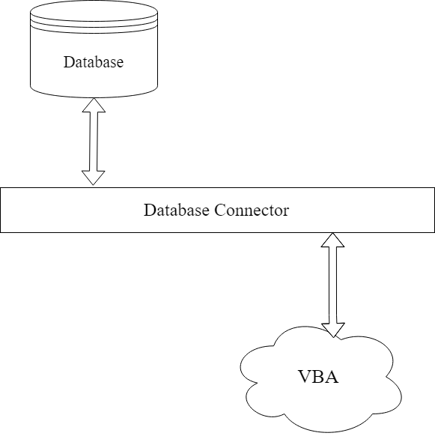

System Context Diagram

## Purpose of Database

The Livant Enterprises database serves as a repository of both real-time and non-real-time operational data for the system. In Release 1, the database will contain data pertaining to the College of Pharmacy Community Outreach Program including session information, patient demographic information, medication information, over-the-counter medication information, immunization information and patient medical condition information. The database will also provide on-demand report-generation functionality.

High-level overview of the system using an activity diagram.

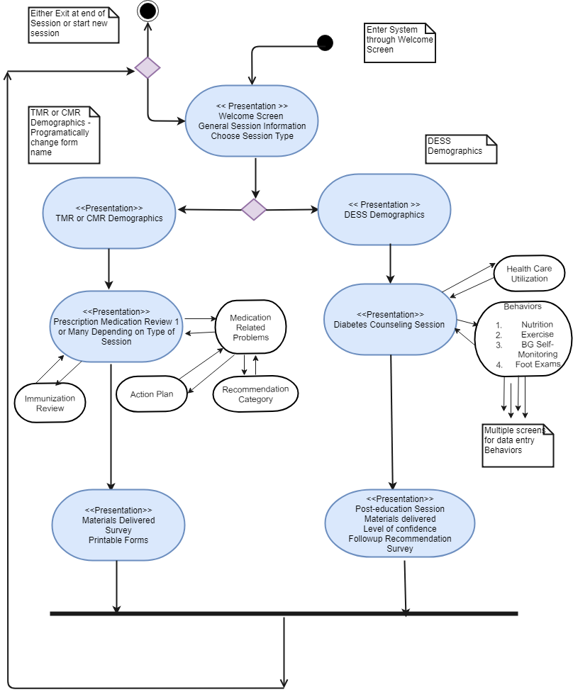

System Activity Diagram

# Data and User Experience Description

This section describes the data requirements and front-end functioning needed for the Pharmacy Outreach Program to continue to provide necessary counselling to Providence, RI area senior citizens at adult daycare centers and convicted criminals in correctional facilities. The information was created by the end user and includes both data description and user experience requirements. This was compiled and written by Dr. Ramos-DeSimone. It is important to note that much of the information comes from patient’s prescriptions, but prescriptions are not entered into the database so there is no table for prescriptions to be stored.

## Comprehensive Medication Review (CMR) or Targeted Medication Review (TMR)

Legend:

|  |  |
| --- | --- |
| Textbox | (TB) |
| Drop down list | (DDL) |
| Radio Button | (RB) |
| Check boxes | (CB) |

The referenced tables follow the data lists

### Session Information

1. Date (TB)
2. RPh (TB)
3. Type of Session (DDL) CMR or TMR
4. Prep Time (TB)
5. Start time (TB)
6. End time (TB)
7. Session Time (DDL) **See table
8. Documentation time (TB)

### Demographics

1. Patient name (TB)
2. Patient Number (TB)
3. Age (TB)
4. Age category (DDL) ** See table
5. Date of Birth (TB)
6. Gender (DDL) ** See table
7. Race (DDL) ** See table
8. Ethnicity (DDL) ** See table
9. Insurance Plan (TB)
10. MTM Insurance Payor Information (TB)
11. Number of Pharmacies (DDL) **See table
12. Mail order? (DDL) (Yes/No)
13. Primary Care Physician (TB)
14. Physician Phone (TB)
15. Medication allergies (TB)
16. Chronic Health Conditions (CB) ** See Table
17. Reason for CMR/TMR (DDL) ** See table

### Prescription Medication Review

(Expandable section for every medication)

1. Drug Category ** See table
2. Medication Name (TB)
3. Part D Drug Class (DDL) ** See table
4. Part D Drug Class (DDL) ** See table
5. Strength (TB)
6. Unit (DDL) ** See table
7. Instructions (DDL) ** See table
8. Indication (DDL) ** See table
9. How long taking? (DDL) ** See table
10. Adherence (DDL) Yes/No
11. Side Effects (DDL) Yes/No
12. Administration Technique (DDL) Yes/No
13. Formulary Friendly (DDL) Yes/No
14. Medical History (TB)
15. Medication Related Problem (DDL) (Expandable section to accommodate multiple problems for each medication) ** See table
16. Recommendations Category (DDL) (connected to the above expandable section to accommodate a recommendation for each Medication Related Problem) ** See table
17. Medication Action Plan (TB) (connected to the above expandable section to accommodate a Medication Action Plan for each Medication Related Problem)
18. Follow-up Recommendation (DDL) ** See table
19. Materials Delivered (CB) ** See table

### Immunizations Review

1. Vaccines Received (CB) **See table
2. Vaccine Recommendations (DDL) (Expandable section) ** See table
3. Comments (TB) (Expandable section)

### Survey after MTM Services

(5 questions each with DDL for answers)

1. Question (DDL) ** See table
2. Answer (DDL) ** See table

### Printable Forms

#### Health Care Provider Form:

1. Include demographics, Prescription Medication Review, and Immunizations Review

## CMR/TMR Tables for Drop Down Lists or Check Boxes

### Session Information:

#### (7) Session Time

|  |
| --- |
| **Session Time** |
| 15 minutes |
| 30 minutes |
| 45 minutes |
| 1 hour |
| 1.25 hours |
| 1.5 hours |

#### Demographics:

**(12) Age Category**

|  |
| --- |
| **AGE Category** |
| < = 64 |
| 65-74 |
| > = 75 |

#### (14) Gender

|  |
| --- |
| **GENDER** |
| Male |
| Female |

#### (15) Race (Check Boxes)

|  | |
| --- | --- |
| **Race** | **Race SPA** |
| White | Blanco |
| American Indian or Alaska Native | Nativo de Alaska o Indio Americano |
| Asian | Asiático |
| Black or African American | Afroamericano o Negro |
| Native Hawaiian or Other Pacific Islander | Nativo de las Islas de Hawái o del Pacifico |

#### (16) Ethnicity

|  |  |
| --- | --- |
| **Ethnic Category** | **Ethnic Category SPA** |
| Hispanic or Latino | Hispano o Latino |
| Non- Hispanic or Latino | No es Hispano o Latino |

#### (19) Number of Pharmacies

|  |
| --- |
| **# Pharmacies** |
| 0 |
| 1 |
| 2 |
| 3+ |

#### (24) Chronic Health Conditions (CB)

|  |  |
| --- | --- |
| Chronic Health Conditions |  |
| Diabetes | Anticoagulation |
| Hypertension | Other |
| Dyslipidemia |  |
| Chronic heart Failure (CHF) |  |
| End Stage Renal Disease |  |
| Cardiovascular Disorders |  |

#### (25) Reason for CMR/TMR

|  |  |
| --- | --- |
| Reason for Medication Review | Razones para la revisión de medicamentos |
| To obtain a complete list of my medications | Obtener una lista complete de mis medicamentos |
| To understand what my medications are for | Entender para que son mis medicamentos |
| To know when to take my medications | Saber cuándo puedo tomar mis medicamentos |
| To see if my medications interact | Ver si mis medicamentos interaccionan |
| To review how take or use my medications | Revisar como administrar mis medicinas |

### Prescription Medication Review

#### (26) Drug Category

|  |
| --- |
| **Category** |
| **Prescription** |
| **over-the-counter** |
| **Dietary Supplement** |
| **Herbal** |

#### (28 &29) Part D Drug Class

|  |
| --- |
| **Part D Drug Classes** |
| ACE-Inhibitors |
| Alpha Blockers |
| Angiotensin Receptor Blockers (ARBs) |
| Antiarrhythmics |
| Anticoagulants |
| Anticonvulsants |
| Antidepressants |
| Antiemetics |
| Antihyperlipidemics |
| Antihypertensives |
| Antineoplastics |
| Antiplatelets |
| Antipsychotics |
| Antiretroviral Therapy |
| Beta Blockers |
| Bisphosphonates |
| Bronchodilators |
| Calcium Channel Blockers |
| Disease-Modifying Anti-Rheumatic Drugs (DMARDs) |
| Diuretics |
| Inhaled Corticosteroids |
| Insulins |
| Interferons |
| Oral Hypoglycemics |
| Proton Pump Inhibitors |
| Selective Serotonin Reuptake Inhibitors (SSRIs) |
| Tumor Necrosis Factor (TNFs) |
| Other: |
| Other: |
| Other: |
| Other: |
| Other: |

#### (31) Unit of Dose

| **Daily Dosing Units** | |
| --- | --- |
| **Units** | **Units SPA** |
| ½ to 1 tab | 1/2 o 1 tableta |
| ½ to 1 tablets | 1/2 o 1 tableta |
| 1 and 1/2 tablets | 1 & 1/2 tableta |
| 1 capful | 1 tapa |
| 1 capsule | 1 capsula |
| 1 drop | una gota |
| 1 injection | 1 inyección |
| 1 patch | un parcho |
| 1 puff | una inhalación |
| 1 spray | 1 aerosol |
| 1 spray | 2 aerosoles |
| 1 tablet | 1 tableta |
| 1 to 2 puffs | 1 o 2 inhalaciones |
| 1 To 2 tablets | 1 o 2 tabletas |
| 1 to 2 teaspoonful | 1 o 2 cucharaditas |
| 1 teaspoon | una cucharada |
| 1/2 tablet | 1/2 tableta |
| ½ to 1 tablet | 1/2 o 1 capsula |
| 10 units | 10 unidades |
| 2 capsules | 2 capsulas |
| 2 puffs | 2 inhalaciones |
| 2 sprays | dos aerosoles |
| 2 tablets | 2 tabletas |
| 2 to 4 tablets | 2 a 4 tabletas |
| 2 teaspoonful | 2 cucharadas |
| 20 units | 20 unidades |
| 3 capsules | 3 capsulas |
| 3 tablets | 3 tabletas |
| 4 capsules | 4 capsulas |
| 4 Tabs | 4 tabletas |
| 5 tab | 5 tabletas |
| 7 &1/2 tabs | 7 &1/2 tabletas |
| 8 tablets | 8 tabletas |
| cream | crema |
| infusion | infusión |
| injection | inyección |
| insulin units | unidades de insulina |
| IU | Unidades Internacionales |
| ointment | ungüento |
| packet | paquete |
| packets | paquetes |
| powder | polvo |
| taper | Disminución |
| units | unidades |

#### (32) Instructions

|  | |
| --- | --- |
| **Description** | **Description SPA** |
| once daily | una vez al día |
| two times a day | dos veces al día |
| three times a day | tres veces al día |
| four times a day | cuatro veces al día |
| once a week | una vez en semana |
| once a month | una vez al mes |
| every other day | alternando los días |
| as directed | según indicado |
| as needed | Cuando necesite |
| at bedtime | Antes de acostarse |

#### (33) Indication

|  | |
| --- | --- |
| **Description** | **Description SPA** |
| Acid reflux (GERD) | Reflujo estomacal |
| Allergies | Alergias |
| Alzheimer’s Disease | Enfermedad de Alzheimer |
| Anemia | Anemia |
| Angina | Angina |
| Anxiety | Ansiedad |
| Anxiety/sleep | Insomnio |
| Arrhythmia | Arritmia |
| Arthritis | Artritis |
| Asthma | Asma |
| Atrial fibrillation | Fibrilación auricular |
| Bipolar Disorder | Trastorno Bipolar |
| Blood Thinner | Anticoagulante |
| Breast cancer | Cáncer del seno |
| Bronchitis | Bronquitis |
| Carpal Tunnel Syndrome | Tendinitis de la muñeca |
| Cataracts | Cataratas |
| Chest Pain | Dolor en el pecho |
| Cholesterol | Colesterol |
| Cold | Resfriado |
| Cold sores | Ronchas en los labios |
| Constipation | Estreñimiento |
| COPD | Enfermedad obstructiva crónica del pulmón |
| Coronary Artery Disease (CAD) | Enfermedad Coronaria |
| Cough | Tos |
| Cramps | Calambres |
| Dental Health | Salud dental |
| Depression | Depresión |
| Dermatitis | Dermatitis |
| Diabetes | Diabetes |
| Diarrhea | Diarrea |
| Dizziness | Mareos |
| Does not know | No sabe |
| Dry eyes | Ojos secos |
| Edema | Hinchazón |
| Energy | Energía |
| Erectile Dysfunction | Disfunción eréctil |
| Eyes | Ojos |
| Fungal infection | Infección de hongo |
| Gastroparesis | Gastroparesia |
| Glaucoma | Glaucoma |
| Gout | Gota |
| Gum Problems | Problemas en las encías |
| Hallucinations | Alucinaciones |
| Headache | Dolor de cabeza |
| Heart | Corazón |
| Congestive Heart Failure (CHF) | Fallo cardiaco |
| Hiatal Hernia | Hernia esófago |
| High Blood Pressure (HTN) | Presión alta |
| Hormone | Hormona |
| Hypokalemia | Potasio bajo |
| Hypothyroidism | Tiroides baja |
| Incontinence | Incontinencia |
| Infection | Infección |
| Interstitial Cystitis | Cistitis |
| Iron Deficiency | Deficiencia de hiero |
| Irritable Bowel Syndrome (IBS) | Síndrome del intestino irritable |
| Kidney Stones | Piedras en los riñones |
| Low Potassium | Potasio bajo |
| Lupus (SLE | Lupus |
| Macular Degeneration | Degeneración macular |
| Memory | Memoria |
| Menopausal Symptoms | Síntomas de menopausia |
| Migraine | Migraña |
| Moderate Pain | Dolor Moderado |
| Moodiness | Estado de animo |
| Multiple Sclerosis (MS) | Esclerosis múltiple |
| Muscle Relaxant | Relajante muscular |
| Narcolepsy | Narcolepsia |
| Nausea | Nausea |
| Neurological Condition | Nervios |
| Neuropathic Pain | Dolor por neuropatía |
| Neuropathy | Neuropatía |
| Osteoarthritis | Osteoartritis |
| Osteoporosis | Osteoporosis |
| Overactive Bladder | Incontinencia |
| Pain | Dolor |
| Pancreatic insufficiency | Insuficiencia pancreática |
| Parkinson’s Disease | Enfermedad de Parkinson |
| Peripheral Edema | Hinchazón |
| Peripheral Vascular Disease (PVD | Enfermedad vascular periférica |
| Platelets | Plaquetas |
| Pregnancy/Breastfeeding | Embarazo |
| Prevention | Prevención |
| Prostate | Próstata |
| Psoriasis | Soriasis |
| Psoriatic Arthritis | Artritis psoriásica |
| Psychotic Disorders | Desórdenes psicóticos |
| Pulmonary Hypertension | Hipertensión pulmonar |
| Rash | Sarpullido |
| Reflux | Reflujo estomacal |
| Restless Leg | Piernas inquietas |
| Rheumatoid Arthritis | Artritis reumática |
| Rosacea | Rosácea |
| Schizoaffective Disorder | Desorden esquizoafectivo |
| Seizures | Epilepsia |
| Shortness of Breath | Falta de aire |
| Skin irritation | Irritación en la piel |
| Sleep | Dormir |
| Smoking Cessation | Dejar de fumar |
| Spasms | Espasmos |
| Stroke | Ataque cerebral |
| Stroke Prevention | Prevención ataque cerebral |
| Swelling | Hinchazón |
| Syncope | Desmayo |
| Tachycardia | Taquicardia |
| Thyroid | Tiroides |
| Tremor | Temblores |
| Ulcerative Colitis | Colitis |
| Ulcers on Feet | Ulceras en los pies |
| Urinary Retention | Retención de orina |
| Urinary Tract Infection | Infección de orina |
| UTI prophylaxis | Prevención de infección de orina |
| Vaginal Itch | Picor vaginal |
| Vertigo | Vértigo |
| Vitamin B 12 Deficiency | Deficiencia de vitamina B12 |
| vitamin D deficiency | Deficiencia de vitamina D |

#### (34) How long taking?

|  | |
| --- | --- |
| **How long taking?** | **How long taking? SPA** |
| < 1 year | < 1 año |
| 1-5 years | 1 a 5 años |
| >5 years | >5 años |

#### (40) Medication Related Problem

|  |
| --- |
| **COMMENT_CODE** |
| I1 Medication without indication |
| I2 Duplicate therapy |
| I3 Indication without medication |
| M1 Lab test indicated |
| S1 Dose too high |
| S2 ADR |
| S3 Drug interaction |
| S4 High risk medication |
| S5 Unnecessary drug |
| E1 Dose too low |
| E2 Improper drug |
| E3 Expired medication |
| E4 Time of day |
| A1 Failure to receive therapy |
| A2 Overutilization |
| A3 Administration challenges |
| A4 Cost |
| A5 Med organization |
| A6 Does not understand instructions |
| A7 Prefers not to take |
| D1 Self screening of BP |
| D2 Self screening of diabetes |
| D3 Lifestyle modifications |
| D4 Patient care referrals |
| D5 Routine tests |
| D6 Disease state education |
| D7 Self-care recommendation |

#### (41) Recommendations Category

|  |
| --- |
| Recommendations |
| Review technique of administration |
| Review indications |
| Provided drug education |
| Initiate Drug |
| Change drug |
| Increase home monitoring |
| Discontinue or substitute drug |
| Referral: Disease Management |
| Referral: Specialty Management |
| Referral: Case Management |

#### (43) Follow-up Recommendation

|  |
| --- |
| Follow-up |
| Meet in one month |
| Meet in 3 months |
| Meet in 6 months |
| Meet in one year |

#### (44) Materials Delivered (CB)

|  |
| --- |
| **Materials Delivered** |
| Written CMR Summary |
| Wallet Card |
| Medication History |
| Lab History |
| Alternative Language Translations |

### Immunizations Review

#### (45) Vaccines Received (CB)

|  |
| --- |
| Vaccines Received |
| Influenza |
| PPSV23 |
| PCV13 |
| HepA |
| HepB |
| Zoster Recombinant |
| Zoster Live |
| Varicella |
| Tdap |
| Td |
| MMR |
| Other |

#### (46) Vaccine Recommendations

|  |
| --- |
| Recommendations |
| Needs Flu vaccine |
| Needs Pneumonia vaccine |
| Needs Shingles vaccine |
| Needs Tetanus vaccine |
| Needs Hepatitis B vaccine |
| Needs to update records with PCP |

## Diabetes Education and Support Session (DESS)

Legend:

Table 3

|  |  |
| --- | --- |
| Textbox | (TB) |
| Drop down list | (DDL) |
| Radio Button | (RB) |
| Check boxes | (CB) |

### Demographics

1. Patient name (TB)
2. Patient Number (TB)
3. Age (TB)
4. Age category (DDL) **See table
5. Date of Birth (TB)
6. Gender (DDL) **See table
7. Race (DDL) **See table
8. Ethnicity (DDL) ** See table
9. Insurance Plan (TB)
10. Number of Pharmacies (DDL) ** See table
11. Mail order? Yes/No
12. Primary Care Physician (TB)
13. Physician phone (TB)
14. Medication allergies (TB)
15. Chronic Health Conditions (CB) **See table
16. Diabetes Counseling Payor: Health Insurance (TB)

### Diabetes Counseling Session

(expandable section for each section to represent various counseling sessions)

#### Session Information

17a. Date (TB)

1. RPh (TB)
2. Prep Time (TB)
3. Start time (TB)
4. End time (TB)
5. Session Time (DDL)**See table
6. Documentation time (TB)
7. Reason for Session (DDL) ** See table

#### Diabetes laboratories

1. A1C (TB)
2. Systolic (TB)
3. Diastolic (TB)
4. Blood glucose (pre-prandial) (TB)
5. Blood glucose (post-prandial) (TB)
6. Random glucose (TB)
7. HDL (TB)
8. LDL (TB)
9. Triglycerides (TB)
10. Cholesterol (TB)
11. Weight (TB)
12. Height (TB)
13. BMI (TB)
14. Perception of Health (DDL) ** See table
15. Patient’s Level of Confidence of DM-blood sugar control (DDL) ** See table
16. Patient’s Level of Confidence -weight control (DDL) ** See table
17. Patient’s Level of Confidence of DM-medication management (DDL) ** See table
18. Patient’s Level of Confidence of DM-exercise (DDL) ** See table

#### Health Care Utilization

1. Dental Care (DDL) ** See table
2. Foot Care (DDL) ** See table
3. Eye Care (DDL) ** See table
4. Immunizations (CB) **See table
5. Visits to primary care physician due to diabetes? (DDL) ** See table
6. Visits to ER due to diabetes? (DDL) ** See table
7. Hospitalizations due to diabetes? (DDL) ** See table

#### Behaviors

1. Nutrition (Expandable Section)
   1. Behaviors (DDL) **See table
   2. Barriers (DDL) **See table
   3. Recommendations/ Comments (TB)
   4. Intervention Type (DDL) **See table
2. Exercise (Expandable Section)
   1. Behaviors (DDL) **See table
   2. Barriers (DDL) **See table
   3. Recommendations/ Comments (TB)
   4. Intervention Type (DDL) **See table
3. BG Self-Monitoring (Expandable Section)
   1. Behaviors (DDL) **See table
   2. Barriers (DDL) **See table
   3. Recommendations/ Comments (TB)
   4. Intervention Type (DDL) **See table
4. Foot Exams (Expandable Section)
   1. Behaviors (DDL) **See table
   2. Barriers (DDL) **See table
   3. Recommendations/ Comments (TB)
   4. Intervention Type (DDL) **See table

#### Post-educational Session

1. Patient’s Perception of Level of Confidence of DM Self-management (DDL) **See table
2. Materials Delivered (CB) **See table
3. Follow-up recommendation (DDL) ** See table

#### Survey Diabetes Counseling Services

(5 questions each with DDL for answers)

1. Question (DDL) **See table
2. Answer (DDL) **See table

## DESS Tables for Drop Down Lists or Check Boxes

### Demographics:

#### (4) Age Category

|  |
| --- |
| **AGE Category** |
| < = 64 |
| 65-74 |
| > = 75 |

#### (6) Gender

|  |
| --- |
| **GENDER** |
| Male |
| Female |

#### (7) Race (Check Boxes)

|  | |
| --- | --- |
| **Race** | **Race SPA** |
| White | Blanco |
| American Indian or Alaska Native | Nativo de Alaska o Indio Americano |
| Asian | Asiático |
| Black or African American | Afroamericano o Negro |
| Native Hawaiian or Other Pacific Islander | Nativo de las Islas de Hawái o del Pacifico |

#### (8) Ethnicity

|  |  |
| --- | --- |
| **Ethnic Category** | **Ethnic Category SPA** |
| Hispanic or Latino | Hispano o Latino |
| Non- Hispanic or Latino | No es Hispano o Latino |

#### (10) Number of Pharmacies

|  |
| --- |
| **# Pharmacies** |
| 0 |
| 1 |
| 2 |
| 3+ |

#### (15) Chronic Health Conditions (CB)

|  |  |
| --- | --- |
| Chronic Health Conditions |  |
| Diabetes | Anticoagulation |
| Hypertension | Other |
| Dyslipidemia |  |
| Chronic heart Failure (CHF) |  |
| End Stage Renal Disease |  |
| Cardiovascular Disorders |  |

### Session Information:

#### (21) Session Time

|  |
| --- |
| **Session Time** |
| 15 minutes |
| 30 minutes |
| 45 minutes |
| 1 hour |
| 1.25 hours |
| 1.5 hours |

#### (23) Reason for Session

|  |  |
| --- | --- |
| Reason for DESS | Razones para la DESS |
| To review diabetes medications | Revisión de los medicamentos para la diabetes |
| To review lifestyle modifications | Revisión de los cambios en el estilo de vida |
| To review nutrition | Revisión de los hábitos de nutrición |
| To review insulin administration | Revisión de la administración de insulina |
| To review foot exam | Revisar como examinar los pies |
| To review glucose monitoring | Revisión de la medición de azúcar en la sangre |

### Diabetes laboratories

#### (37) Perception of Health

|  |  |
| --- | --- |
| **Perception of Health** | **Percepción de salud** |
| **Excellent** | **Excelente** |
| **Very good** | **Muy buena** |
| **Good** | **Buena** |
| **Fair** | **Regular** |
| **Poor** | **Mala** |

#### (38-41) Patient’s Perception of Level of Confidence od DM Self-management

|  |  |
| --- | --- |
| **Perception** | **Percepción** |
| 1 Strongly Disagree | 1 Estoy en desacuerdo |
| 2 Disagree | 2 desacuerdo |
| 3 Neutral | 3 Neutral |
| 4 Agree | 4 en acuerdo |
| 5 Strongly Agree | 5 Muy acuerdo |

### Health Care Utilization

#### (42) Dental

#### (43) Foot care

#### (44) Eye Care

|  |  |
| --- | --- |
| **Health Care Utilization** | **Health Care Utilization SPA** |
| One year | Un año |
| 6 months | 6 meses |
| 3 months | 3 meses |
| 1 month or less | 1 mes o menos |

#### (45) Immunizations

|  |
| --- |
| Vaccines Received |
| Influenza |
| PPSV23 |
| PCV13 |
| HepA |
| HepB |
| Zoster Recombinant |
| Zoster Live |
| Varicella |
| Tdap |
| Td |
| MMR |
| Other |

#### (46-48) Visits and hospitalizations

|  |
| --- |
| **Number of times per year** |
| 0 |
| 1 |
| 2 |
| 3 |
| 4 or more |

#### (53) Level of confidence

|  |  |
| --- | --- |
| **Perception** | **Percepción** |
| 1 Strongly Disagree | 1 Estoy en desacuerdo |
| 2 Disagree | 2 desacuerdo |
| 3 Neutral | 3 Neutral |
| 4 Agree | 4 en acuerdo |
| 5 Strongly Agree | 5 Muy acuerdo |

#### (54) Materials Delivered (CB)

|  |
| --- |
| **Materials Delivered** |
| Written DESS Summary |
| Educational Materials |
| Reminder List |
| BG Monitoring Diary |
| Alternative Language Translations |

#### (55) Follow-up Recommendation

|  |
| --- |
| Follow-up |
| Meet in one month |
| Meet in 3 months |
| Meet in 6 months |
| Meet in one year |

## Logical Organization of Data

This section describes the raw data without redundancies and without information that is stored elsewhere.

### Session

Session Date

Session Rph

Session Type

Session Prep Time

Session Start Time

Session End Time

Session Time

Session Documentation Time

Session Reason

Facility

### Demographics

Patient Name

Patient DOB

Patient Age

Patient Age category

Patient Gender

Patient Race

Patient ethnicity

### Insurance

Cardholder ID

Plan Name

Plan Bin

Plan PCN

Plan Group

### Pharmacy

Number of Pharmacies

Mail order

### Prescriber

PCP Name

PCP Phone number

### Health Data

Medication history

Chronic Health Conditions

Allergies

A1C

Systolic

Diastolic

Fasting Glucose

After eating Glucose

Random Glucose

HDL

LDL

Triglycerides

Cholesterol

Weight

Height

BMI

### Immunizations

Vaccines Received

Vaccine Recommendations

Comments

### Patient Diabetes Behavior Information

Level of Confidence before session

* Blood sugar control
* Weight control
* Medication management
* Exercise

Level of Confidence after session

Dental Care

Foot Care

Eye Care

Visits to PCP

Visits to ER

Visits to Hospital

Nutrition

Behaviors

Barriers

Recommendations / comments

Intervention Type

Exercise

Behaviors

Barriers

Recommendations / comments

Intervention Type

BG Self-Monitoring

Behaviors

Barriers

Recommendations / comments

Intervention Type

Foot Exams

Behaviors

Barriers

Recommendations / comments

Intervention Type

### Drug

Category

Name

Part D1

Part D2

Strength

Unit

### Survey

5 questions and answers

### Med Review – TMR / also used in CMR

Medication

Instructions

Indication

How long taking?

Adherence

Side Effects

Administration technique

Formulary Friendly

Medication related problem(s)

Recommendations Category

Follow-up Recommendations

### Materials Delivered

# Logical Design and Models

This section describes the logical design and the various data models of the URI Pharmacy Outreach Program relational database management system. Each of the data models which compromises the logical design are described, as well as data usage within the Livant Enterprises System. Draw.io, an open platform to create and share diagrams, is used to support database design activity. Microsoft VBA in Excel is used to model and create the user front-end experience. The information within this section is not intended to replace the relational database management system repository, but rather to briefly summarize the information within the repository.

The PC used for the development is a Dell Inspiron 5379 2-in-1 Laptop with Windows 10 Home Version 10.0.17134 Build 17134. This is a 64-bit System with 8 Gig memory, 1 TB Hard drive, Intel Core i5 processor running at 1.60 GHz.

# Conceptual Model for Database

The database is designed as a warehousing system. The database was designed utilizing Draw.io for the initial ER Diagram. MySQL Workbench 8.0 CE was used to create architectural blueprint for the finished database. The database is implemented also using the MySQL Workbench 8.0 CE. The database organization is reflected in the schema diagrams that follow.

## System Schema Design Model

System Schema Design Model

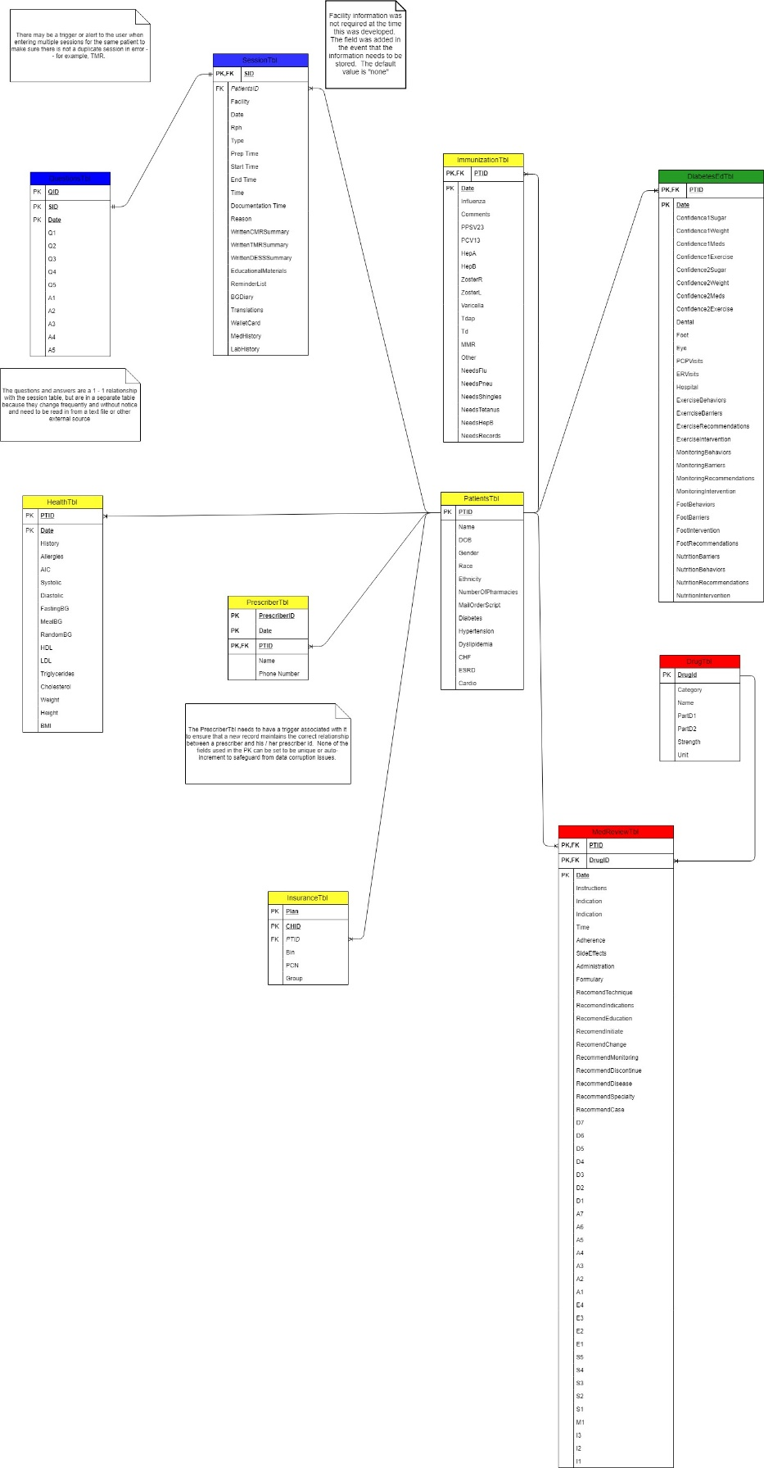

## Administration Model

The Administration (Admin) data model is shown in *Figure 4*. The primary purpose of this section of the model is to support session data, patient data as well as system maintenance and updates. This is a small, single-system model.

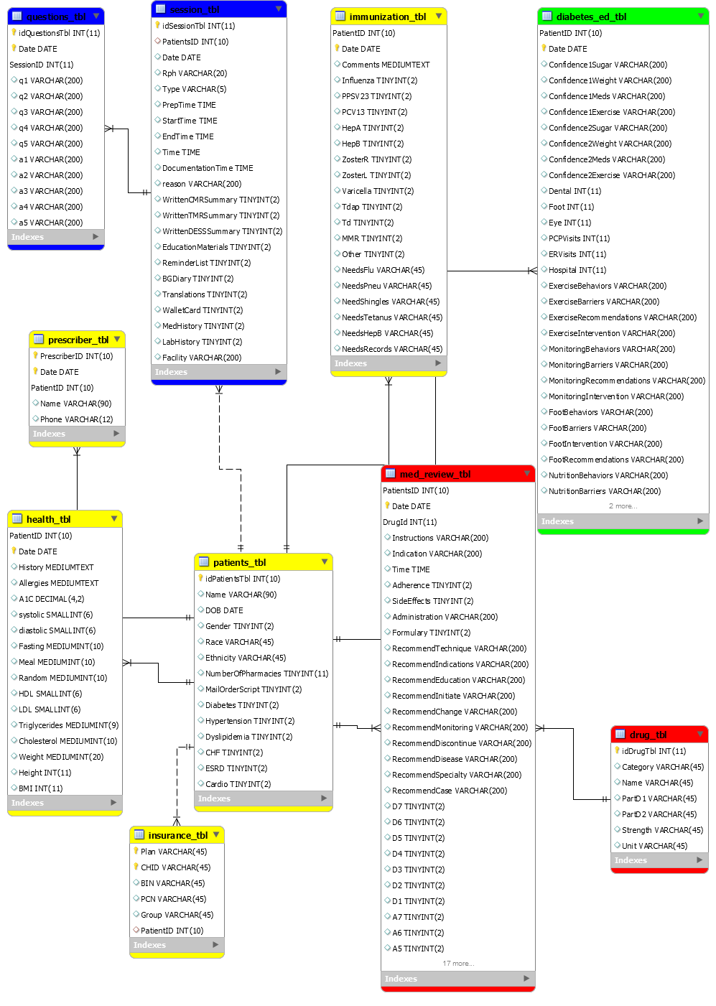

Administration Model

## Session Model – export finished database with screenshots of end user functioning

The Session Model data model …The primary purpose of this section of the model is to support the on-site comprehensive medication reviews and individual medication reviews and allow the healthcare professional to print an after-visit summary for the patient.

## Patient Model

The Patient data model is shown in Figure. The primary purpose of this section of the model is to support storage and processing of the patient’s demographic information, allergy information, medication information, over-the-counter medication information, vaccine information and chronic health conditions information.



Patient Model

## Data Usage – Data Movement and ETL ? Extract, Transform and Load

This section describes Livant Enterprises software data ownership (external owner) and usage of tables within the database.

### Data Ownership – data sources

All data within the database is owned by the system; there are no other systems which create, reference, update or delete data. Once data has been entered into the database, Livant Enterprises software clients and subsystems are the sole users of the data.

### Data and Functions

A Create, Reference, Update, Delete (CRUD) matrix for the Livant Enterprises software is presented in Table 3.1. For the purposes of this table, thee verbs have the following meanings:

|  |  |
| --- | --- |
| Create: | The subsystem creates a new row in the subject table directly by executing the equivalent of an SQL INSERT statement. |
| Reference: | The subsystem accesses data within the table directly via an SQL SELECT-FROM statement or clause, or indirectly by setting a trigger on the data. |
| Update: | The subsystem accesses an existing row of the table and modifies a column entry within that row. |
| Delete: | The subsystem deletes row (one or more) from the subject table. |

CRUD Table

|  |  |  |  |  |
| --- | --- | --- | --- | --- |
| **Table** | **Subsystems** | | | |
| Admin | RPH |  |  |
| PATIENT |  |  |  |  |
| DRUG |  |  |  |  |
| OTC |  |  |  |  |
| SESSION |  |  |  |  |
|  |  |  |  |  |
|  |  |  |  |  |

### Business Rules

There are no explicit business rules which the database must enforce. The business rules are enforced by the application software that loads data into the database. Those business rules are embedded into the details of the specifications and design of the application software detailed in the Livant Enterprises Software Design Document.

# Physical Model

This section describes the physical model of the Livant Enterprises database. The physical model is described in terms of the database tables and data dictionary, the physical organization, database constraints and triggers, performance features, database security, and backup and recovery. MySql v… date release # is used to support database design activity. Some of these physical attributes of the database result from activities which occur later in the database implementation activity and are noted as TBD within this section. The information within this section is not intended to replace the Designer repository, but rather to briefly summarize the information within the repository.

## Table Models and Data Dictionary

contains MySQL Table Definition Report. That report contains a complete description of each table, table keys and columns within each table. Appendix C contains MySQL Designer Column Definition Report.

contains MySQL Designer Table, Column and Primary Key Report.

contains MySQL Designer Table, Column and Foreign Key Report.

## Physical Organization

## Database Constraints and Triggers

## Performance Features

## Security

The URI College of Pharmacy controls all system security. All system security risks such as impersonation and denial of service are handled by the department. All other system security is implicit in the system via best system design and best coding practices. The risk of SQL injection is mitigated by the layered architecture and component isolation design. There are no special provisions for database security. Security, privacy, and access are controlled through admin MySQL username-password combinations.

## Backup and Recovery

# Software Activity Diagram



Software Activity Diagram

# System Deployment Diagram

# Notes

# Requirements Traceability